Task 03: Dry Run Program.
Dry Run the following program and fill up the trace table:
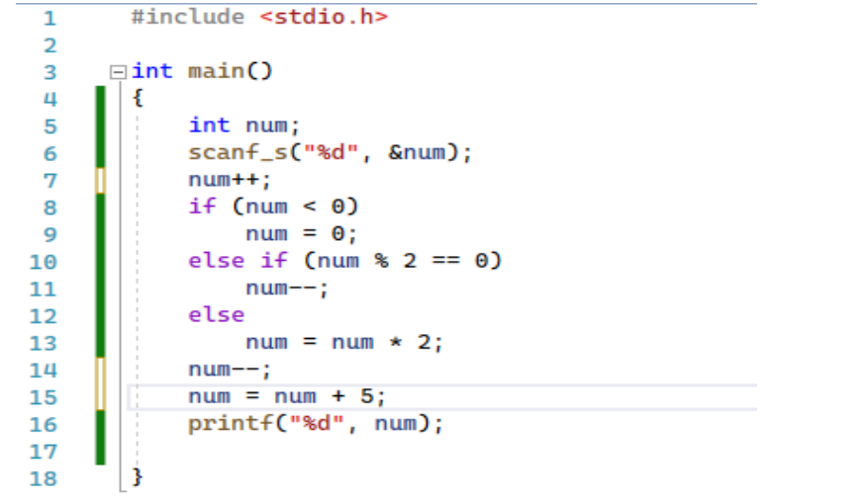

Input | num at line 7 | num at line 14 | Output
1 | 2 | 0 | 5
23 | 24 | 22 | 27
6 | 7 | 13 | 18
72 | 73 | 145 | 150
-12 | -11 | -1 | 4
0 | 1 | 1 | 6
99 | 100 | 98 | 103

